|  |  |
| --- | --- |
|  | **FPT ACADEMY INTERNATIONAL**  **FPT – APTECH COMPUTER EDUCATION** |

**Centre Name: ACE-HCMC-2-FPT.**

**Address: 590 Cach Mang Thang 8, District 3, Ho Chi Minh City, Viet Nam.**

**ITM College**

Installation Guide

|  |  |  |  |
| --- | --- | --- | --- |
| **Center** | | ACE-HCMC-2-FPT | |
| **Instructor** | | Mr. Ngo Phuoc Nguyen | |
| **Class** | | T1.1908.E0 | |
| **Group** | | 1 | |
| **Group members** | | **Name** | **Student ID** |
| Vu Duc Huy | Student1215608 |
| Le Nguyen Minh Ngoc | Student1226455 |
| Huynh Quoc Huy | Student1208501 |
| Luong Vinh Hien | Student1204494 |
| **Assignment** | **Start date** | 28Dec2020 | |
| **End date** | 28Jan2021 | |

1. **Software and Hardware Requirement**
2. **Hardware requirement**

|  |  |
| --- | --- |
| **Component** | **Requirement** |
| **Server** | **Processor type:**  **Pentium III-compatible processor or faster**  **Processor speed:**  **Recommended: 2.0 GHz or faster** |
| **OS** | **Microsoft Windows Server 2003 or higher** |
| **Memory (RAM)** | **RAM:**  **Minimum: 512 MB**  **Recommended: 2.048 GB or more**  **Maximum: Operating system maximum** |
| **Hard Drive** | **Free space:**  **Minimum: 50 MB**  **Recommended: 50 GB or more**  **Maximum: Operating system maximum** |

1. **Software requirement**

|  |  |
| --- | --- |
| **Component** | **Requirement** |
| **Microsoft .NET Framework** | **Version 5.0** |
| **Microsoft Visual Studio** | **Microsoft Visual Studio 2010** |
| **RDBMS** | **Microsoft SQL Server 2008** |

1. **Configuraion**

Dow code : <https://github.com/nana2909/ITM.git>

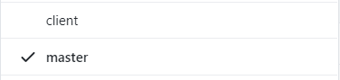

Open file ApiServer

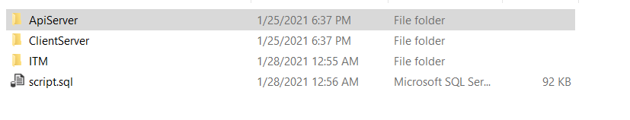

Open File ITMCollege_T11908E0_Team1.sln

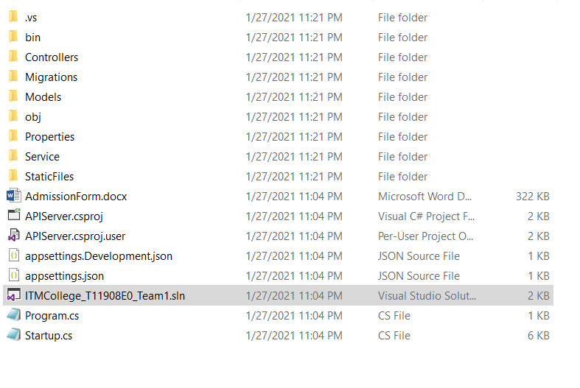

Open Visual Studio -> Tools->NutGet Package Manager ->Package Manager Console

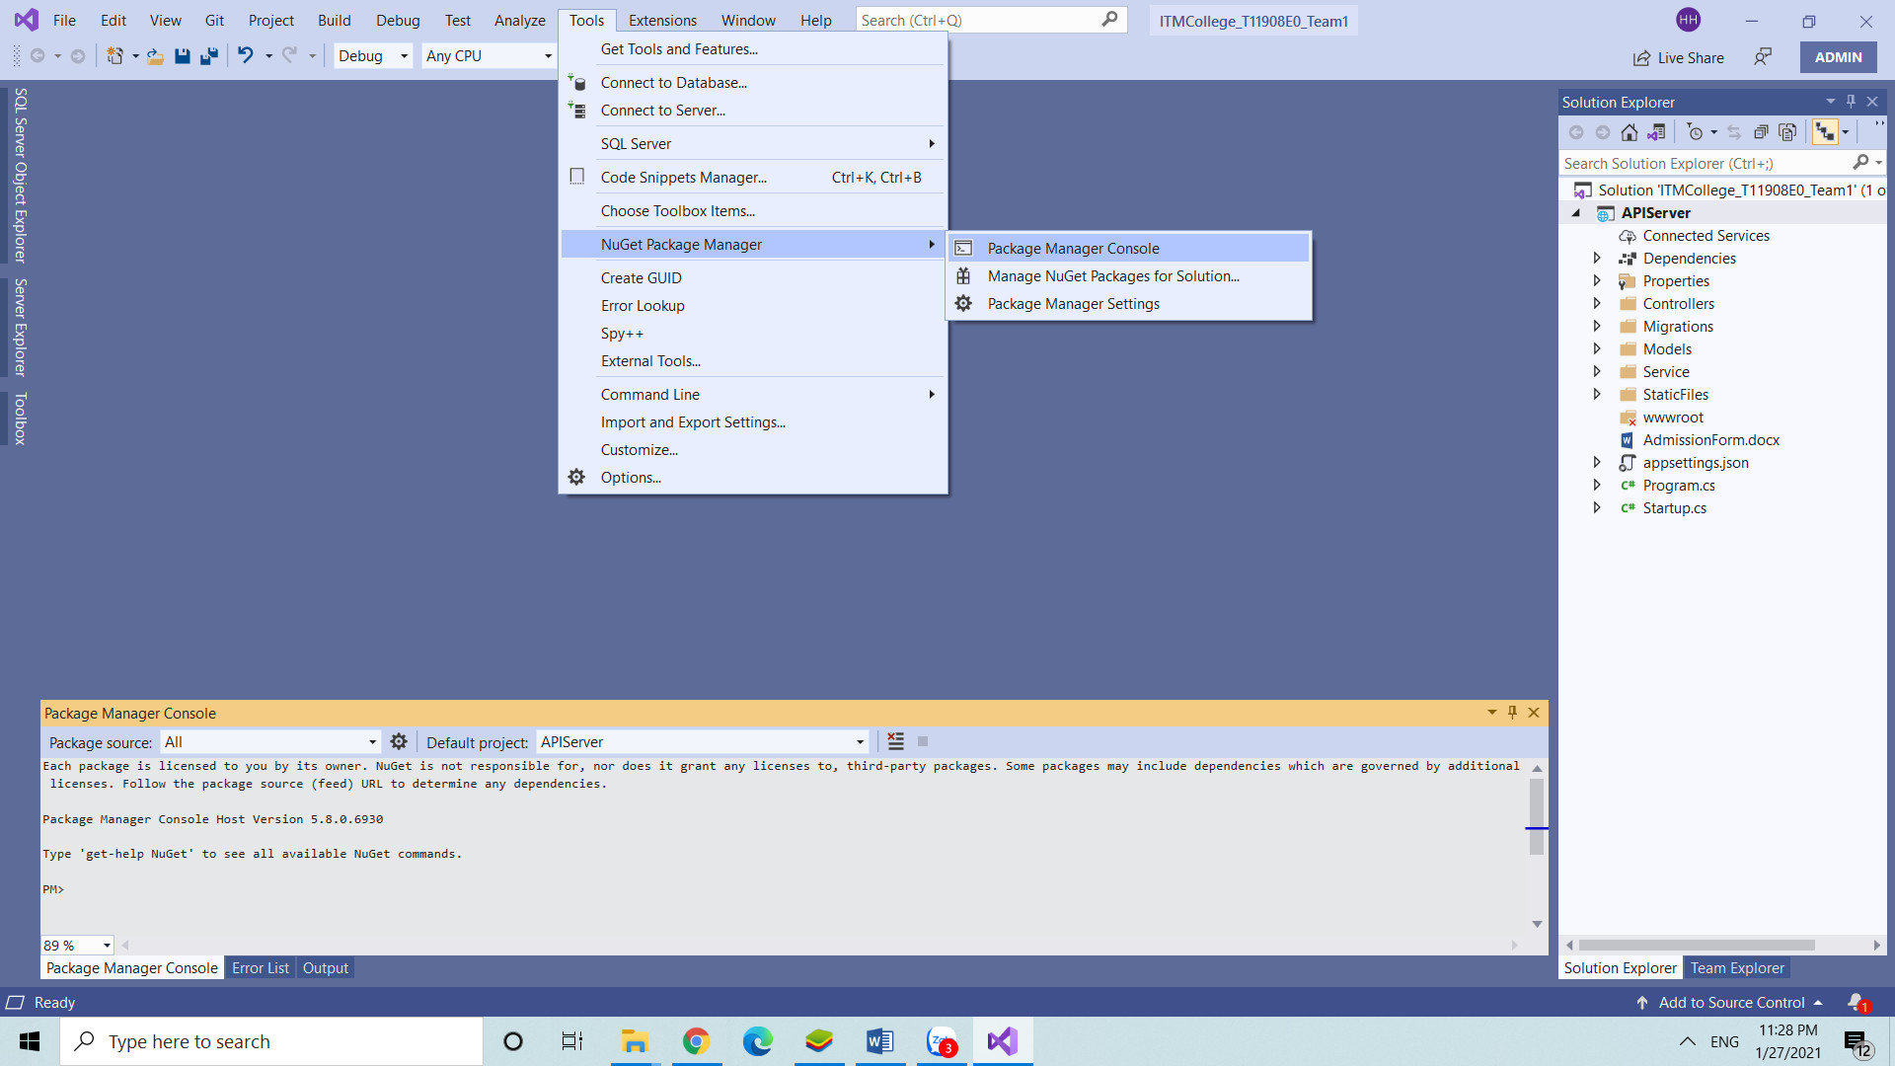

Run code : add migration “create”

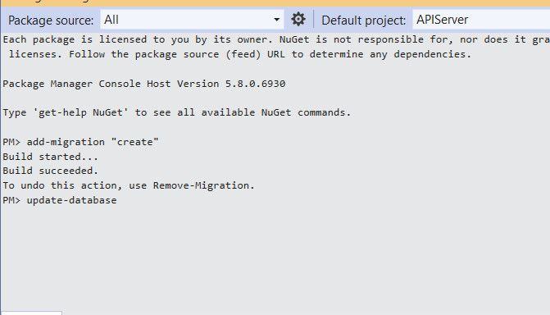

Next run code : update-database



Open File script.sql

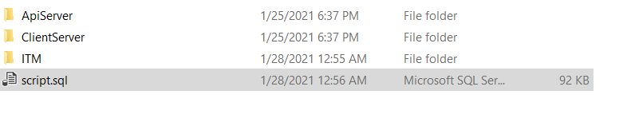

Click Excute export database

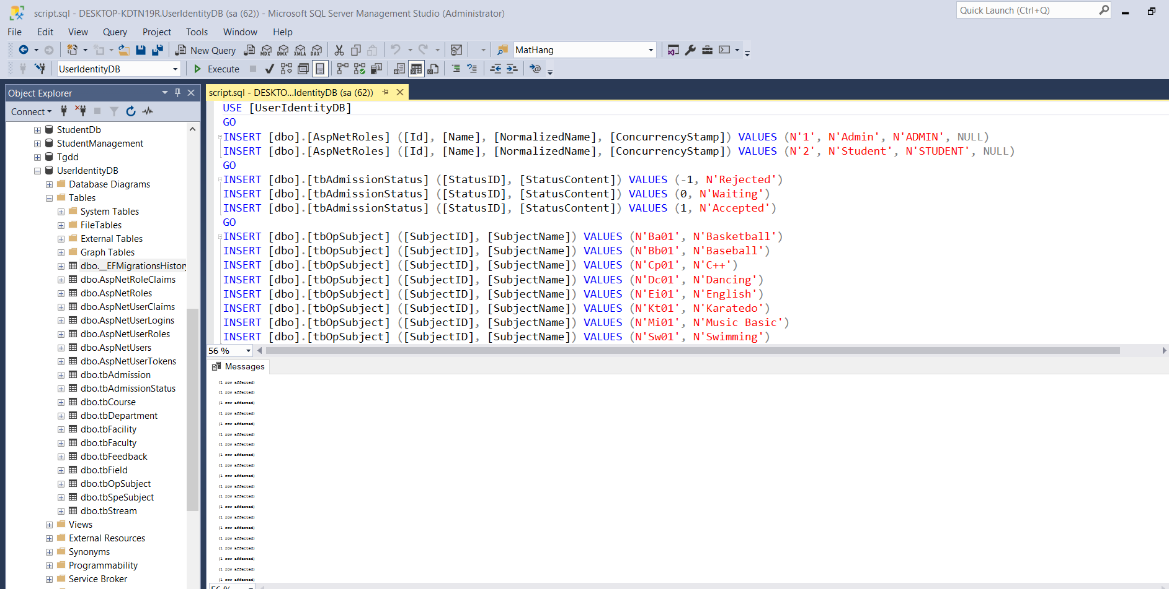

Open visua studio

Press the F5 key to run API server

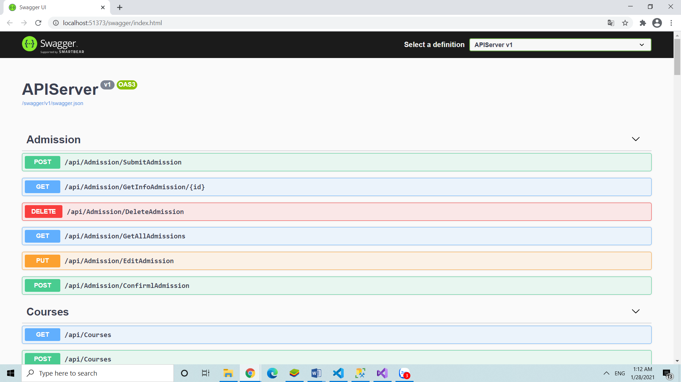

Open Visual Studio Code

Click File -> Open Folder

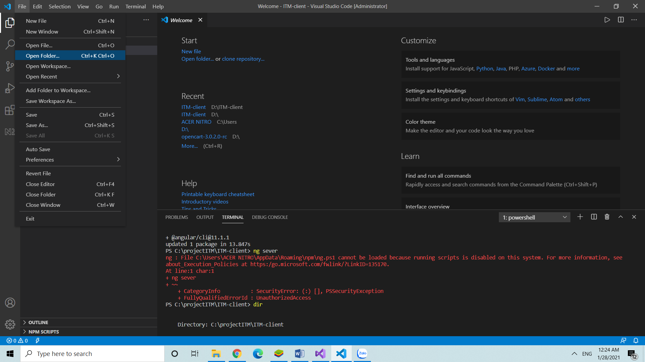

Click ITM -> select Folder

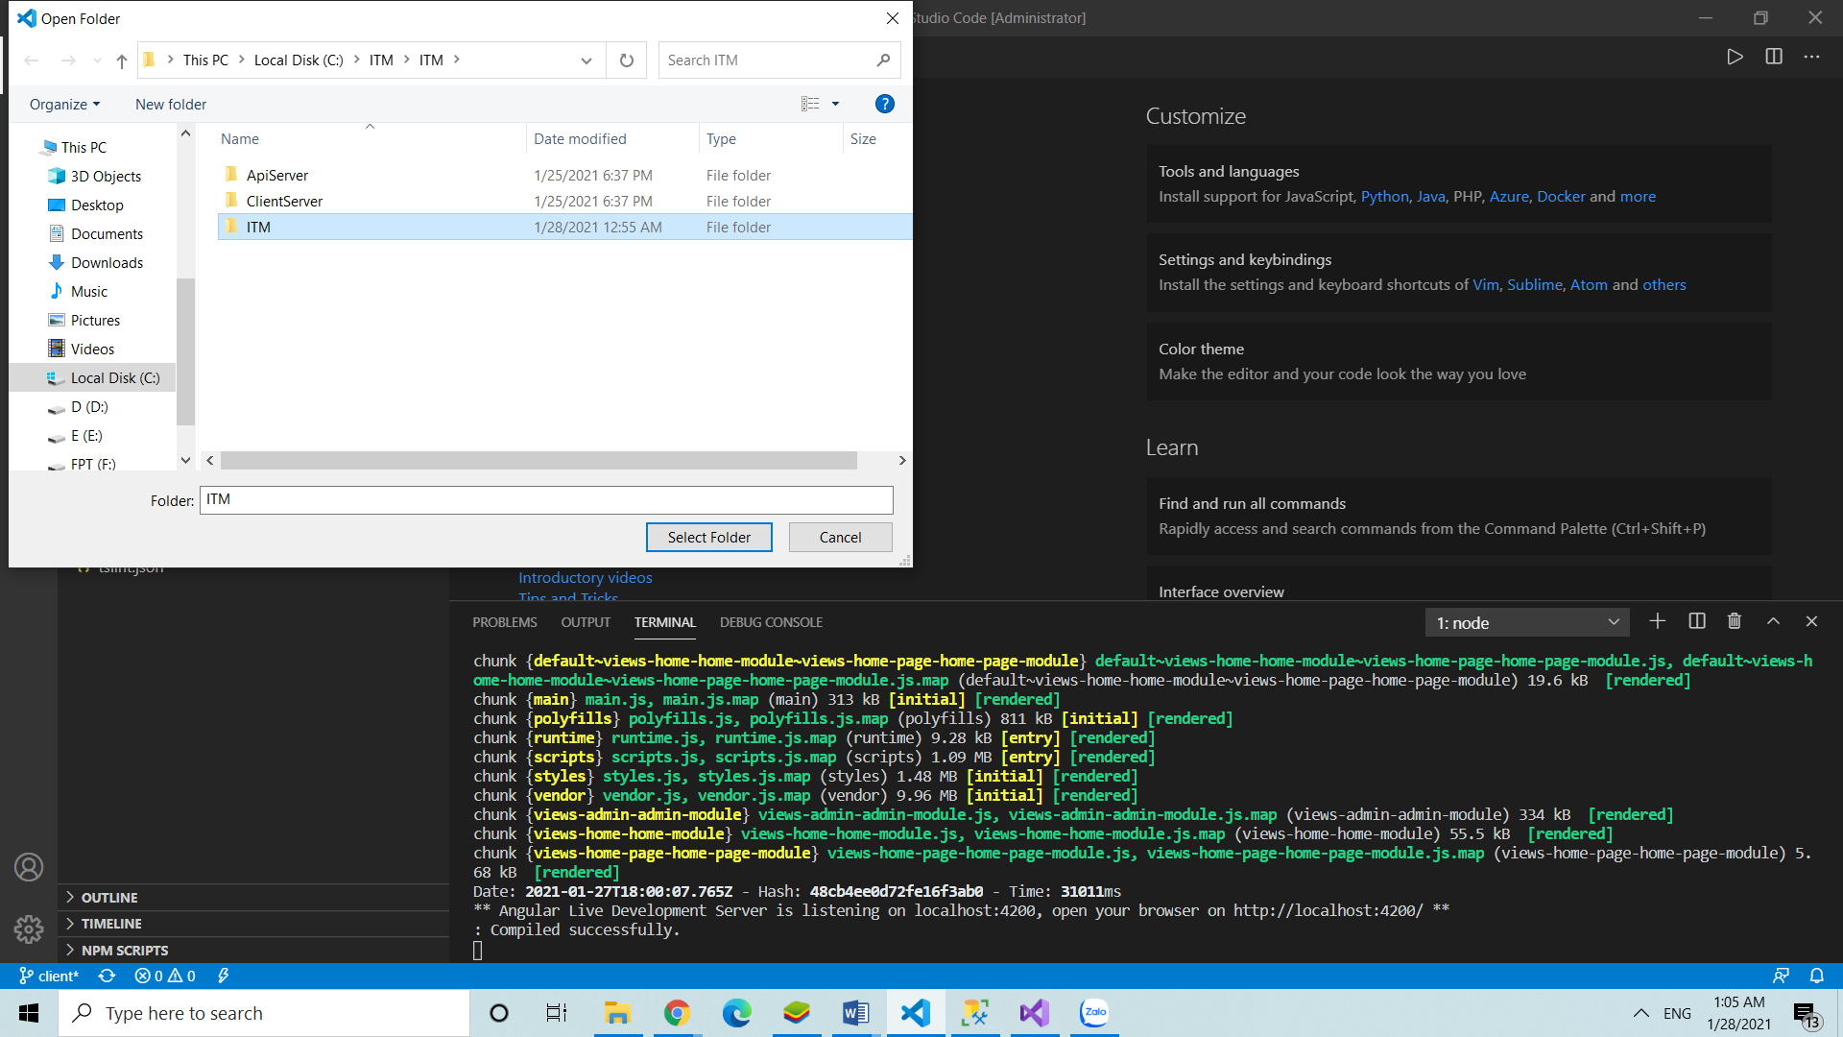

Open Terminal

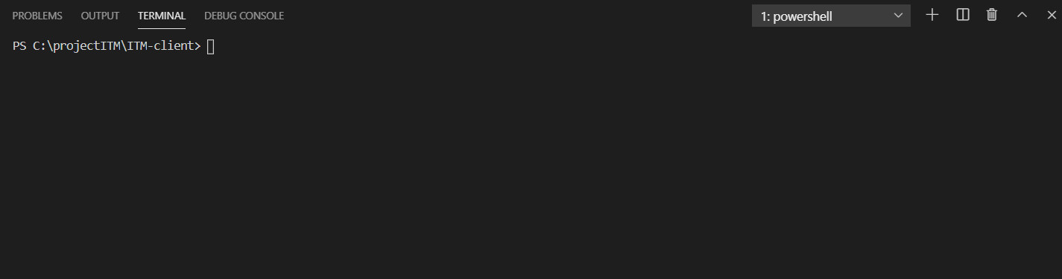

Run code : npm instal

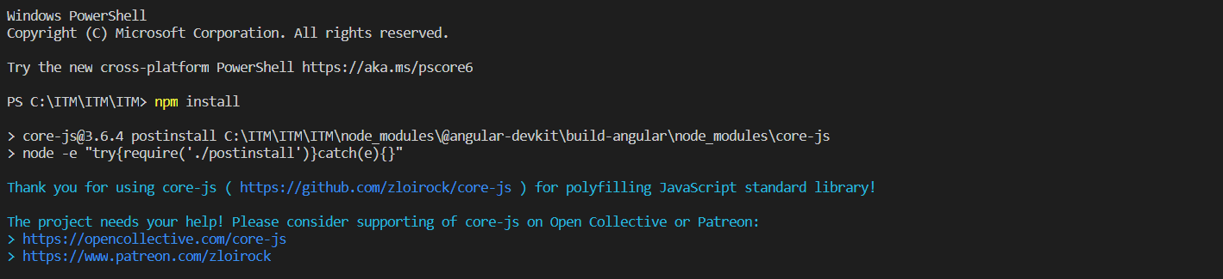

Next code : npm start

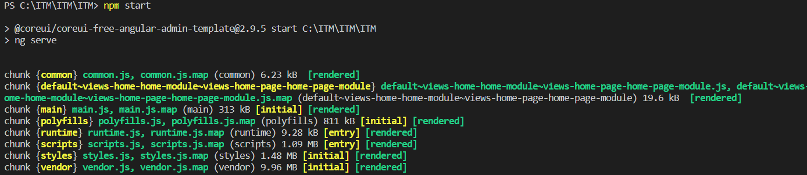

Final click link : http://localhost:4200/ ** to run website client

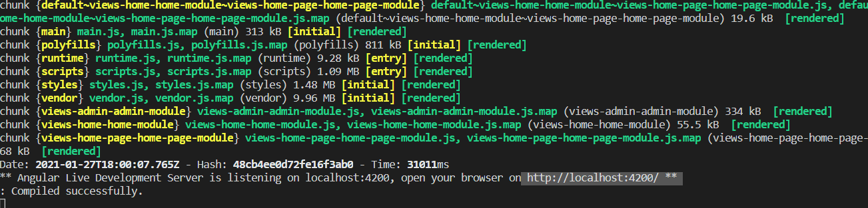

Website is loading in Web-Browser

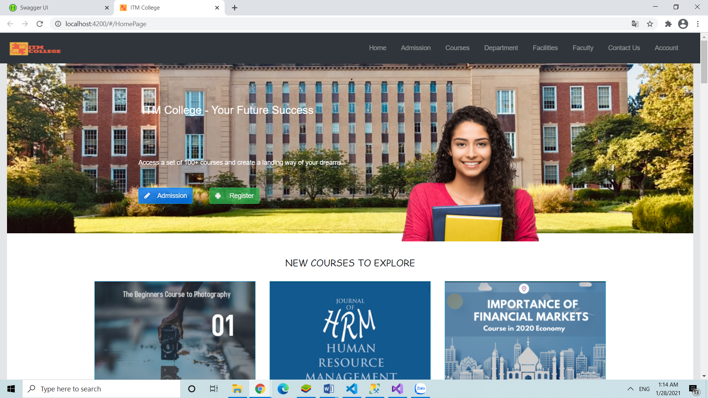

Click ITM-CLIENT

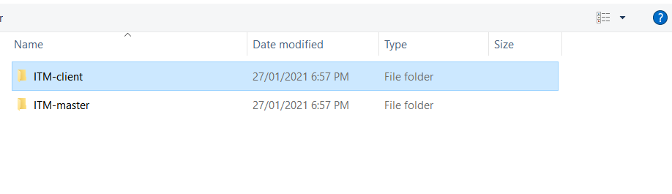

Click Terminal -> New Terminal

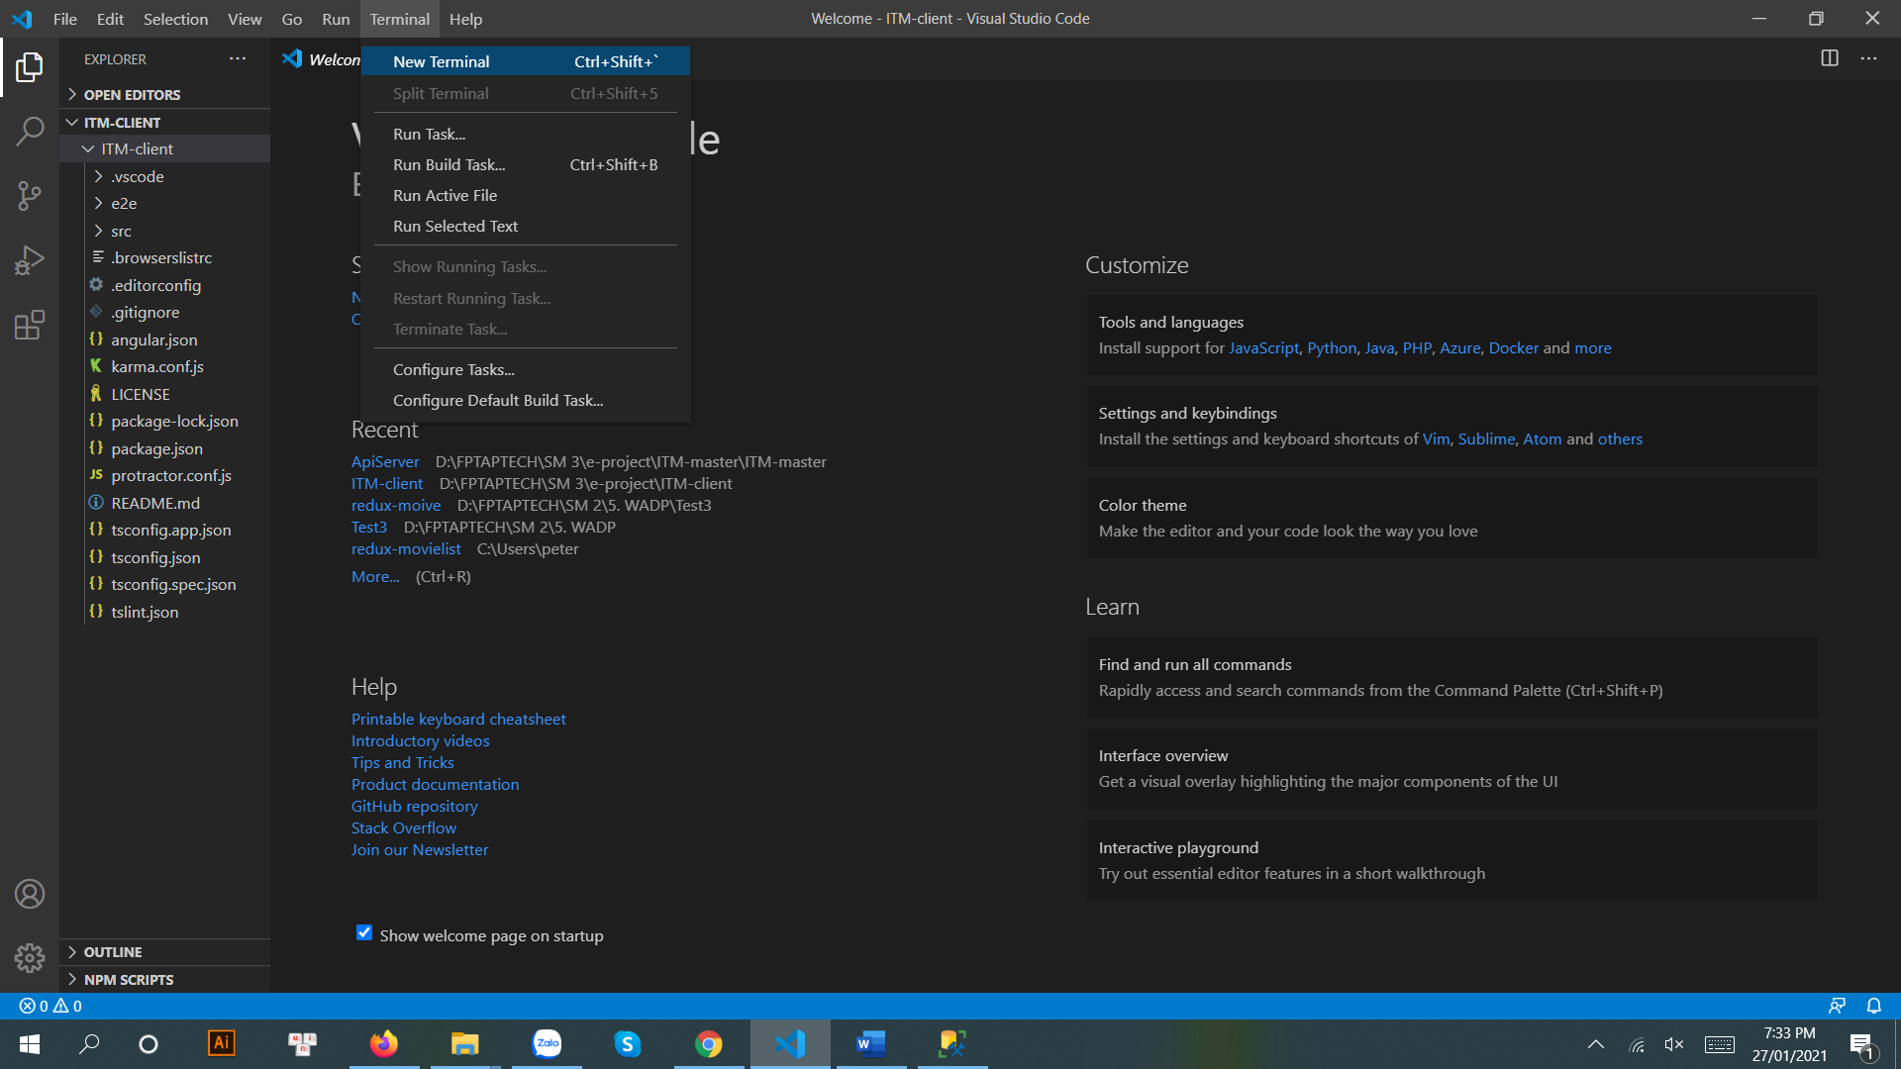

Run npm install -g @angular/cli

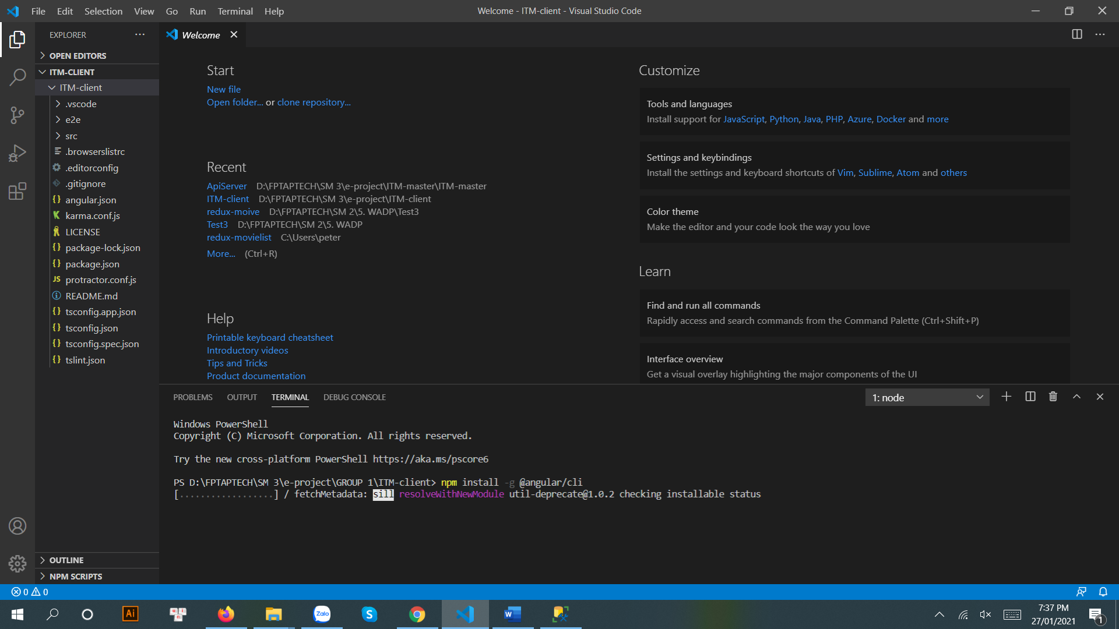

The website is ready

